**SOAP and Web services PDF**

To extract the classes from the existing XML file. For example, using the link: <http://webservices.oorsprong.org/websamples.countryinfo/CountryInfoService.wso?wsdl>

Open the Eclipse (Enterprise Edition only) > Create a new Java Project (Choose Version SE: 1.8) > Inside the project > Select the option New > Other > Search for Web Service Client > Paste the URL and finish. That should provide with the classes.

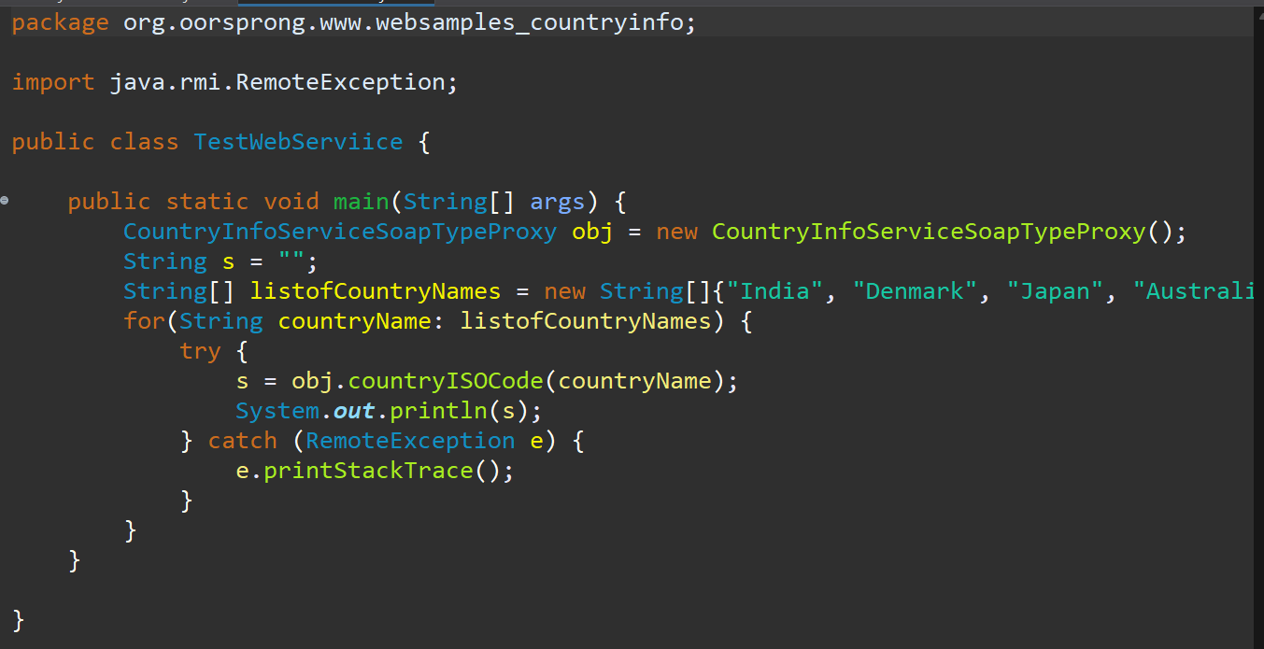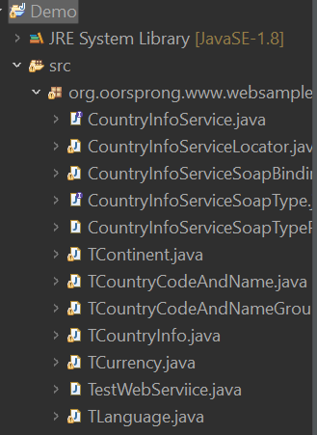 We can use the following by finding a file ending with Proxy > Create a new class in the same package > Then create a new object from the proxy class > Run the code like below:

In this way, we can generate classes from an existing wsdl file and can use it in the local system.

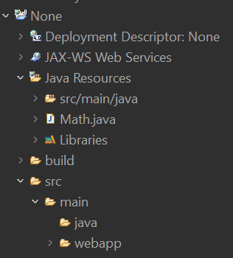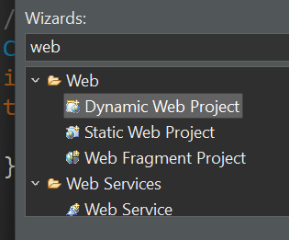For creating our own web service, we can do the following: Create a new Java Project > Dynamic Web Project > Use Apache Tomcat 9.0 > Finish > Click yes on open preceptor > You should see the following:

Create a new class and after adding the desired methods > Right Click > Select web service > Tick on Publish Web service > You should see a new wsdl file like below:

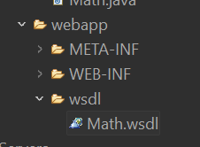You can find the URL in the wsdl file at very bottom like: <http://localhost:8080/None/services/Math> and when you add “?wsdl” at the end, you should see the wsdl.

Now use the same logic as above and can create classes from this URL.

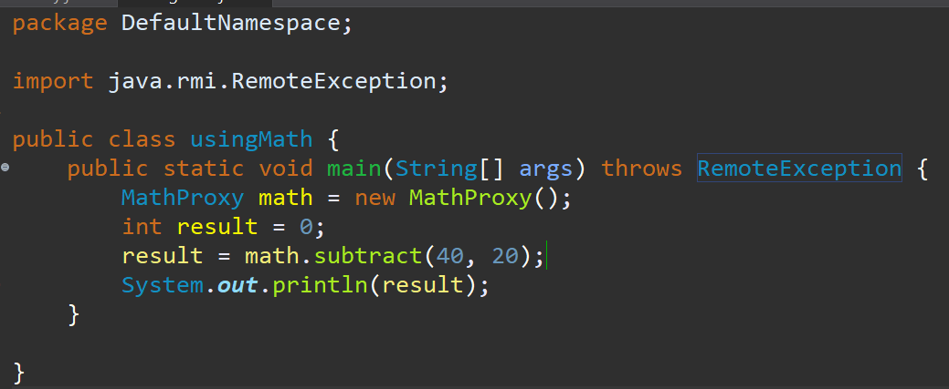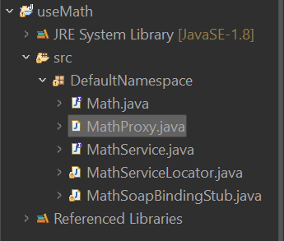Make sure to create a new Project > Then create the web service client to prevent errors.